 | 
Erasmus+ Programme
Key Action 1
– Mobility for learners and staff –
Higher Education Student and Staff Mobility
Inter-institutional agreement 2019-2021
between programme countries
The institutions named below agree to cooperate for the exchange of students and/or staff in the context of the Erasmus+ programme. They commit to respect the quality requirements of the Erasmus Charter for Higher Education in all aspects related to the organisation and management of the mobility, in particular the recognition of the credits awarded to students by the partner institution.
UC Leuven-Limburg, Leuven campus = UC Leuven
UC Leuven-Limburg, Limburg campus = UC Limburg

A. Information about higher education institutions
Name of the institution  (and department, where relevant) | Erasmus code | Contact details  (email, phone) | Website  (eg. of the course catalogue)
UC Limburg | B HASSELT20 | international@ucll.be  +32-11-180007  Faculty International contact(s):  Internationalblt.limburg@ucll.be | https://www.ucll.be/international
UC Leuven | B LEUVEN18 | international@ucll.be  +32-16-375 756  Faculty International contact(s):  Internationalblt.leuven@ucll.be | https://www.ucll.be/international
Università degli Studi di Modena e Reggio Emilia  Dipartimento chirurgico, medico, odontoiatrico e di scienze morfologiche con interesse trapiantologico, oncologico e di medicina rigenerativa. | I MODENA01 | Ufficio Relazioni Internazionali  agreements@unimore.it  Modena campus:  ++39 059 2056568  Dr. Paola Sena  Erasmus coordinator  Via del pozzo, 71. 41124 Modena-IT  e-mail paola.sena@unimore.it  phone:++390594223180 | UNIMORE  http://www.international.unimore.it/  Course Catalogue  http://www.international.unimore.it/study.html  To choose courses (Select: academic year and Department of interest)  https://www.esse3.unimore.it/ListaFacolta.do;jsessionid=CBF24F3AB0EBDFCC1EBEDE57E6EE6899.jvm_unimore_esse3web06?cod_lingua=eng  Erasmus+ at UNIMORE  http://www.international.unimore.it/erasmus.html  www.chimomo.unimore.it

B. Mobility numbers per academic year
If the agreement is signed for more than one academic year:
The partners commit to amend the table below in case of changes in the mobility data by no later than the end of January in the preceding academic year.
FROM  [Erasmus code of the sending institution] | TO  [Erasmus code of the receiving institution] | Subject area code  *  [ISCED] | Subject area name  * | Study cycle  [short cycle, 1st , 2nd or 3rd]  * | Number of student mobility periods
 |  |  |  |  | Student Mobility for Studies or Traineeships
B HASSELT20 | I MODENA01 | 0914 Medical diagnostic and treatment technology |  | 1st | 1 student x 3 months
I MODENA01 | B HASSELT20 | 0914 Medical diagnostic and treatment technology |  | 1st | 1 student x 3 months
B LEUVEN18 | I MODENA01 | 0914 Medical diagnostic and treatment technology |  | 1st | 1 student x 3 months
I MODENA01 | B LEUVEN18 | 0914 Medical diagnostic and treatment technology |  | 1st | 1 student x 3 months

FROM  [Erasmus code of the sending institution] | TO  [Erasmus code of the receiving institution] | Subject area code  *  [ISCED] | Subject area name  * | Number of staff mobility periods
 |  |  |  | Staff Mobility for Teaching  [total number of days of teaching periods or average duration *] | Staff Mobility for Training  *
B HASSELT20 | I MODENA01 | 0914 Medical diagnostic and treatment technology |  | 1 x min. 2d & 8h | 1 x min. 2days
I MODENA01 | B HASSELT20 | 0914 Medical diagnostic and treatment technology |  | 1 x min. 2d & 8h | 1 x min. 2days
B LEUVEN18 | I MODENA01 | 0914 Medical diagnostic and treatment technology |  | 1 x min. 2d & 8h | 1 x min. 2days
I MODENA01 | B LEUVEN18 | 0914 Medical diagnostic and treatment technology |  | 1 x min. 2d & 8h | 1 x min. 2days

C. Recommended language skills
The sending institution, following agreement with the receiving institution, is responsible for providing support to its nominated candidates so that they can have the recommended language skills at the start of the study or teaching period:
Receiving institution  [Erasmus code] | Optional: Subject area | Language  of instruction 1 | Language  of instruction 2 | Recommended language of instruction level
 |  |  |  | Student Mobility for Studies  [Minimum recommended level: B1] | Staff Mobility for Teaching  [Minimum recommended level: B2]
B HASSELT20 |  | English | Dutch | B1 | B2
B LEUVEN18 |  | English | Dutch | B1 | B2
I MODENA01 |  | ITALIAN | ENGLISH  only for Courses taught in English – International Courses: http://www.international.unimore.it/internationalcourses.html | ITALIAN B1 | ENGLISH B2
For more details on the language of instruction recommendations, see the application package of each institution and follow the links in part A.
D. Additional requirements
B HASSELT20 & B LEUVEN18:
All Belgian institutions will consider applications from students with disabilities. Please contact the respective international offices to check the availability of specific support or infrastructure.
UC Limburg expects all students to participate in two days Orientation Days in Diepenbeek.
UC Leuven expects all students to register for and attend the Introduction week in Leuven, prior to the start of the exchange period.

I MODENA01:
The University of Modena and Reggio Emilia has a Disabled People´s Service - http://www.international.unimore.it/disabledoffice.html - who works in the two campuses to attend to the needs of the university population with disabilities, taking into account each person's individual circumstances.
E. Calendar
1. Applications/information on nominated students must reach the receiving institution by:

Receiving institution  [Erasmus code] | Autumn term*  [month] | Spring term*  [month]
B HASSELT20 | June 15th | November 15th
B LEUVEN18 | June 15th | November 15th
I MODENA01 | FIRST SEMESTER DEADLINES:  Nomination: 31 MAY  Application: approximately MID – JUNE  incoming.erasmus@unimore.it  ACADEMIC CALENDAR  https://www.aule.unimore.it/PortaleStudentiUnimore/index.php?view=0  Orientation session/Language course: will be communicated by email | SECOND SEMESTER DEADLINES:  Nomination: 30 SEPTEMBER  Application: approximately MID- OCTOBER  incoming.erasmus@unimore.it  ACADEMIC CALENDAR  https://www.aule.unimore.it/PortaleStudentiUnimore/index.php?view=0  Orientation session/Language course: will be communicated by email

2. The receiving institution will send its decision within 5-8 weeks after the student has completed and sent in all required paperwork related to the mobility application.
I MODENA01 will send its decision within 8 weeks
3. A Transcript of Records will be issued by the receiving institution no later than 5 weeks after the assessment period has finished at the receiving HEI and has been evaluated.
4. Termination of the agreement
The unilateral termination of this agreement before the end date mentioned below must be sent in writing to the partner institution before 15 November or 15 June and will be in effect as of 1 February or 1 September respectively, being the semester following this writing.
Neither the European Commission nor the National Agencies can be held responsible in case of a conflict.

F. Information
1. Grading systems of the institutions
B HASSELT20 & B LEUVEN18: https://www.ucll.be/gradingtables
I MODENA01:
Marks awarded at Italian universities are on a scale from 18 to 30 scale (30 being the highest vote/18 the lowest). If the mark is not over 18 then the exam performance is considered unsatisfactory so no grade is written on the university student’s record book.
A certain number of credits are awarded for each examination. One ECTS credit in the Italian system corresponds to 25 working hours, taking account of all types of activity required (lessons, seminars, individual or group study, etc.). So 1 CFU (Credito Formativo Universitario) is equivalent to 1 ECTS credit. Statistical distribution of grades according to the descriptions in the ECTS users' guide will be available at: http://www.international.unimore.it/ects.html .

2. Visa
The sending and receiving institutions will provide assistance, when required, in securing visas for incoming and outbound mobile participants, according to the requirements of the Erasmus Charter for Higher Education.
Information and assistance can be provided by the following contact points and information sources:
Institution  [Erasmus code] | Contact details  (email, phone) | Website for information
B HASSELT20 | dries.hanssen@ucll.be | https://www.ucll.be/international
B LEUVEN18 | sylvia.collaer@ucll.be | https://www.ucll.be/international
I MODENA01 | International Welcome Desk – Unimore  Ph. 0039 059 2058171  Online services: www.isu-services.it/it/universities/universita-di-modena  Email:internationalwelcomedesk@unimore.it | http://www.international.unimore.it/wdesk.html

3. Insurance
The sending and receiving institutions will provide assistance in obtaining insurance for incoming and outbound mobile participants, according to the requirements of the Erasmus Charter for Higher Education.
The receiving institution will inform mobile participants of cases in which insurance cover is not automatically provided. Information and assistance can be provided by the following contact points and information sources:
Institution  [Erasmus code] | Contact details  (email, phone) | Website for information
B HASSELT20 | valerie.aniol@ucll.be | https://www.ucll.be/international
B LEUVEN18 | odette.vanhorenbeek@ucll.be | https://www.ucll.be/international
I MODENA01 | International Welcome Desk – Unimore  Ph. 0039 059 2058171  Online services: www.isu-services.it/it/universities/universita-di-modena  Email:internationalwelcomedesk@unimore.it | http://www.international.unimore.it/wdesk.html

4. Housing
The receiving institution will guide incoming mobile participants in finding accommodation, according to the requirements of the Erasmus Charter for Higher Education.
Information and assistance can be provided by the following persons and information sources:
Institution  [Erasmus code] | Contact details  (email, phone) | Website for information
B HASSELT20 | Stuvo.limburg@ucll.be | https://www.ucll.be/international
B LEUVEN18 | sylvia.collaer@ucll.be | https://www.ucll.be/international
I MODENA01 | International Welcome Desk – Unimore  Ph. 0039 059 2058171  Online services: www.isu-services.it/it/universities/universita-di-modena  Email: accommodation@unimore.it | http://www.international.unimore.it/wdesk.html

G. SIGNATURES OF THE INSTITUTIONS (legal representatives)
Institution | Name, function | Date | Signature
B HASSELT20 | Mr. Marc Vandewalle  President | 20-06-2019 | 
B LEUVEN18 | Mr. Marc Vandewalle  President | 20-06-2019 | 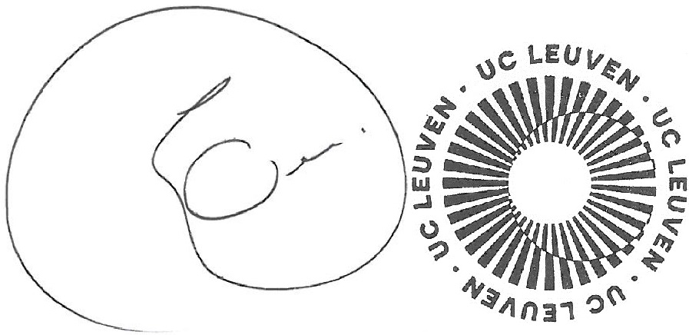
I MODENA01 | Prof. Angelo O. ANDRISANO  RETTORE | 12/7/2019

Contact details to reach the senior officer in charge of this agreement and of its possible updates.
MODENA Campus Departments: Life Sciences; Chemical and Geological Sciences; Physics, Informatics and Mathematics; Economics “Marco Biagi”; Engineering “Enzo Ferrari”; Law; Studies on Language and Culture; Medicine and Surgery; Nursing; Midwifery; Imaging and Radiotherapy Techniques; Biomedical Laboratory Techniques; Dietistic. REGGIO EMILIA Campus Departments: Agronomy; Communication and Economics; Education and Humanities; Engineering Sciences and Methods; Nursing, Occupational Therapy; Physiotherapy; Psychiatric Rehabiitation Techniques.
Mobility numbers can be given per sending/receiving institutions and per education field (optional*: http://www.uis.unesco.org/Education/Pages/international-standard-classification-of-education.aspx)
For an easier and consistent understanding of language requirements, use of the Common European Framework of Reference for Languages (CEFR) is recommended, see http://europass.cedefop.europa.eu/en/resources/european-language-levels-cefr
Scanned signatures are accepted

